# Lab Exercise 12: INTELLIGENT MANAGEMENT

|  |
| --- |
| Enable Int.Man.  Create ODR  Service Policy  Assoc. Ser.Pol.  Enable Health  Health Policy |

## Enable Intelligent Management

## Create an ODR Server

## Create a service policy

## Associate a service policy with an application

## Enable Health Management

## Create a health policy

Enable Int.Man.

Create ODR

Service Policy

Assoc. Ser.Pol.

Enable Health

Health Policy



**Task 1: Enable Intelligent Management**

**Step 1:** Navigate to “Servers>Server Types>Web Servers” and click on server name.

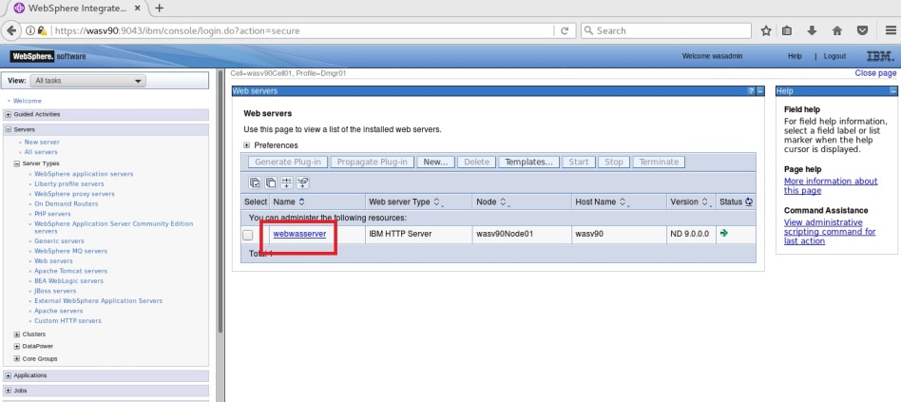

**Step 2:** Click “Intelligent Management” under “Additional Properties”.

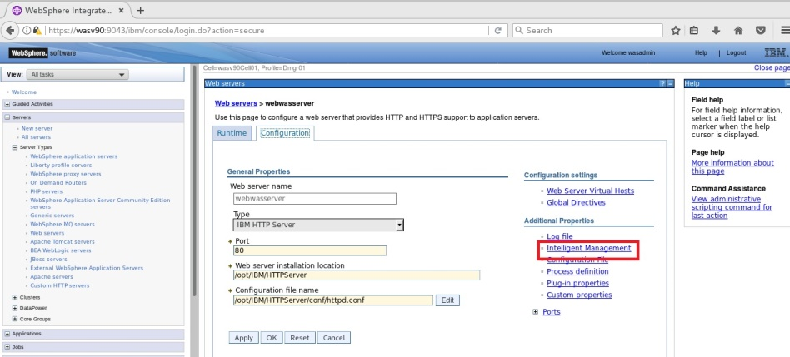

Enable Int.Man.

Create ODR

Service Policy

Assoc. Ser.Pol.

Enable Health

Health Policy



**Step 3:** Mark “Enable” and click “OK”.

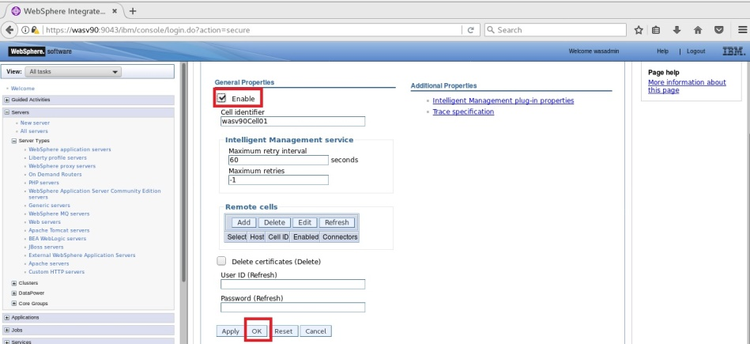

**Step 4:** Click “Save” to write changes directly to the master configuration.

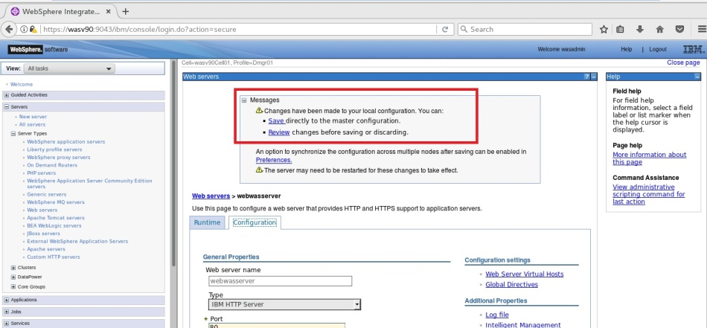

Enable Int.Man.

Create ODR

Service Policy

Assoc. Ser.Pol.

Enable Health

Health Policy



**Step 5:** Select the web server and click “Generate Plug-in”.

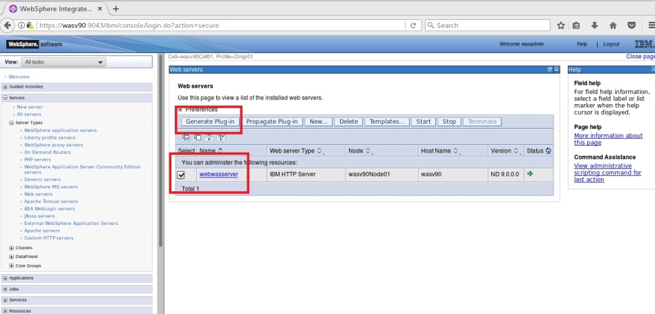

**Step 6:** When new configuration is generated click on “Propagate Plug-in”.

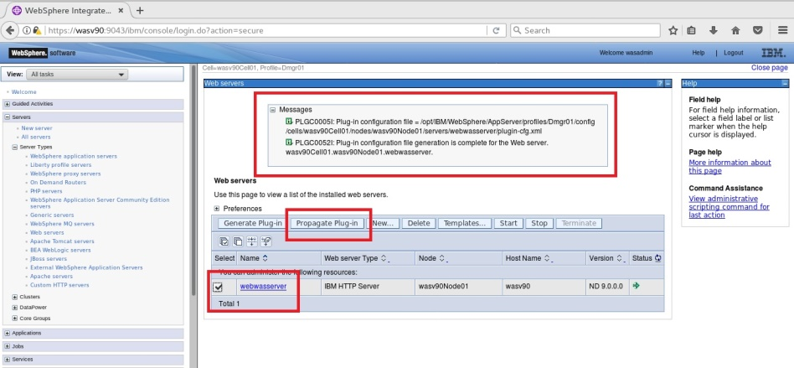

Enable Int.Man.

Create ODR

Service Policy

Assoc. Ser.Pol.

Enable Health

Health Policy



**Step 7:** You should see similar success message as following image.

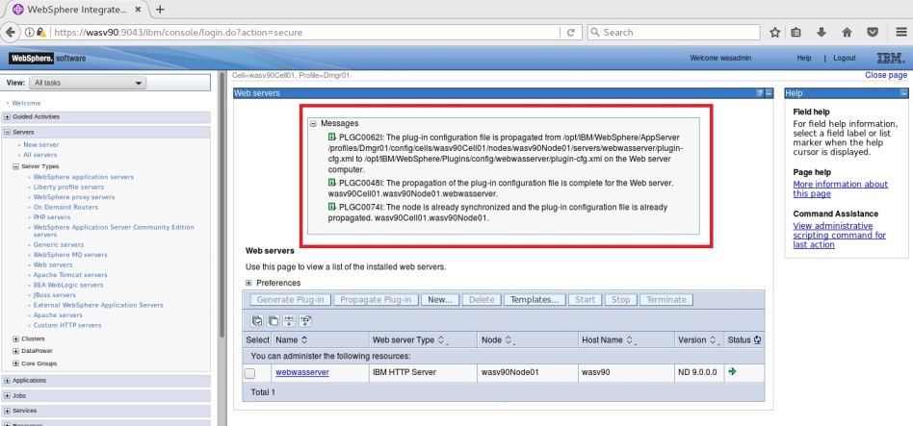

**Task 1 is complete!**

Enable Int.Man.

Create ODR

Service Policy

Assoc. Ser.Pol.

Enable Health

Health Policy



**Task 2: Create an ODR Server**

**Step 1:** Navigate to “Servers>Server Types>On Demand Routers” and click “New”.

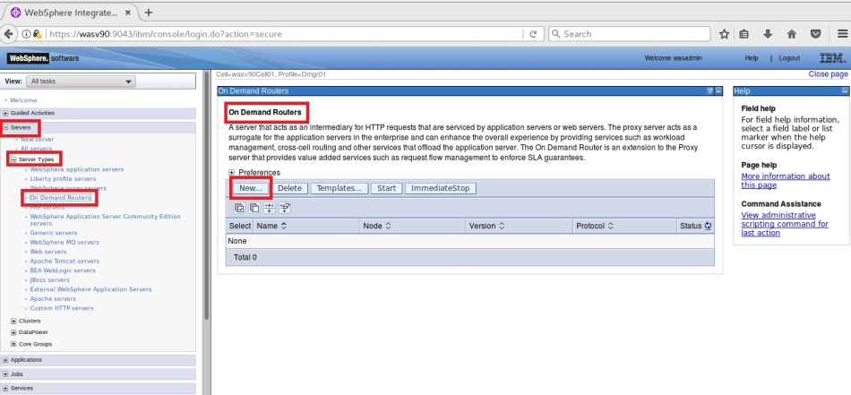

**Step 2:** Select the node you want to install ODR and type a name then click “Next”.

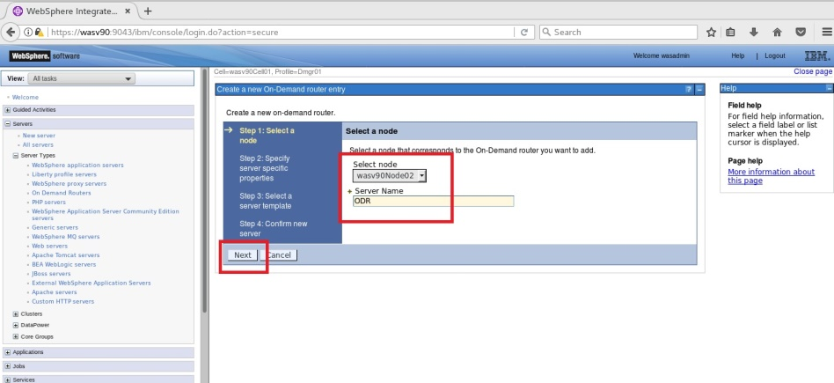

Enable Int.Man.

Create ODR

Service Policy

Assoc. Ser.Pol.

Enable Health

Health Policy



**Step 3:** Just select “HTTP” as supported protocol and click “Next”.

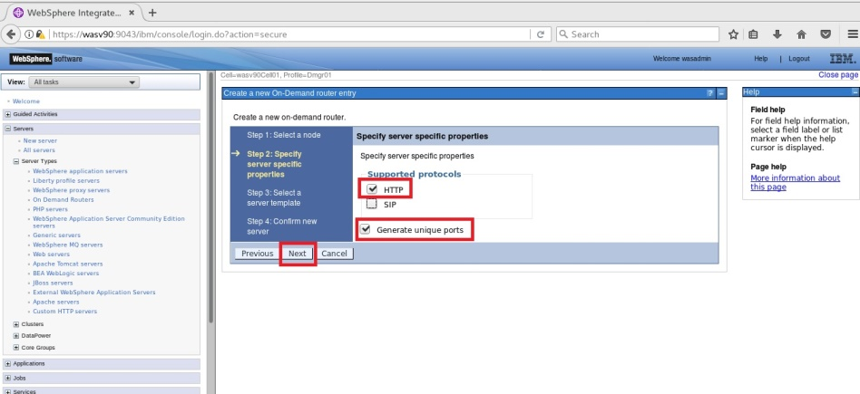

**Step 4:** Click “Next” to continue.

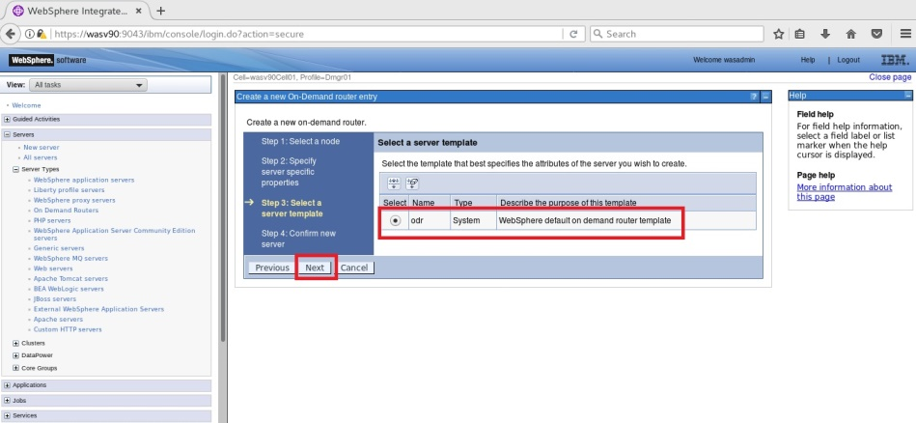

Enable Int.Man.

Create ODR

Service Policy

Assoc. Ser.Pol.

Enable Health

Health Policy



**Step 5:** Review the summary of the actions and click “Finish”.

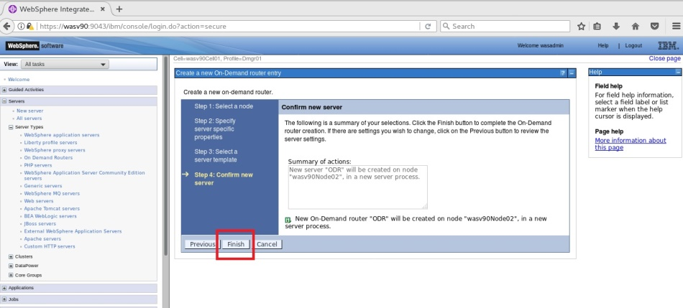

**Step 6:** Click “Save” to write changes to the master file.

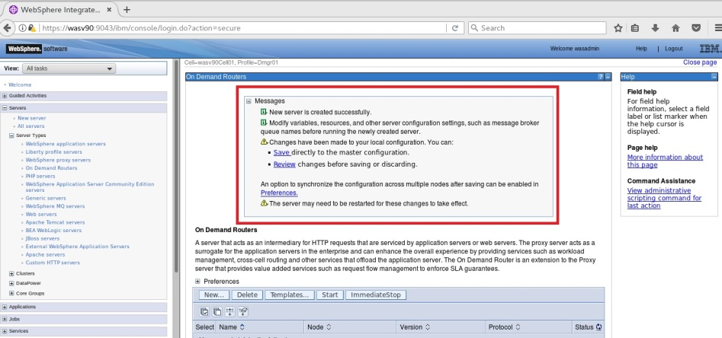

Enable Int.Man.

Create ODR

Service Policy

Assoc. Ser.Pol.

Enable Health

Health Policy



**Step 7:** Select newly created ODR and click “Start”.

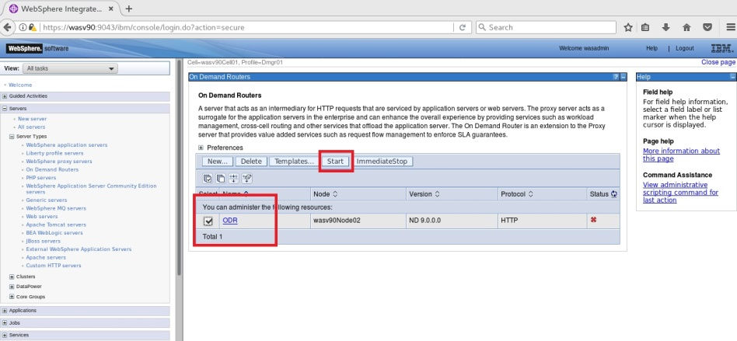

You should see ODR started with success message.

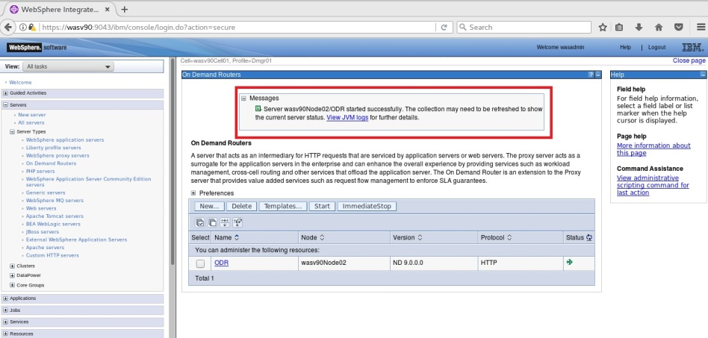

**Task 2 is complete!**

Enable Int.Man.

Create ODR

Service Policy

Assoc. Ser.Pol.

Enable Health

Health Policy



**Task 3: Create a Service Policy**

**Step 1:** Navigate to “Operational policies>Service policies” and click “New”.

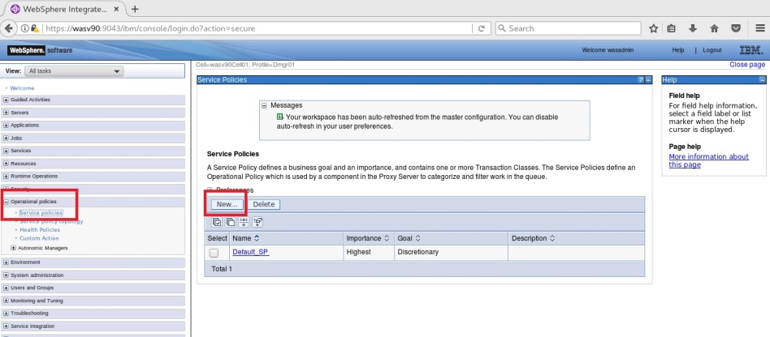

**Step 2:** Type a name for the policy (TOP_SP) and select “Average Response Time” then click “Next”.

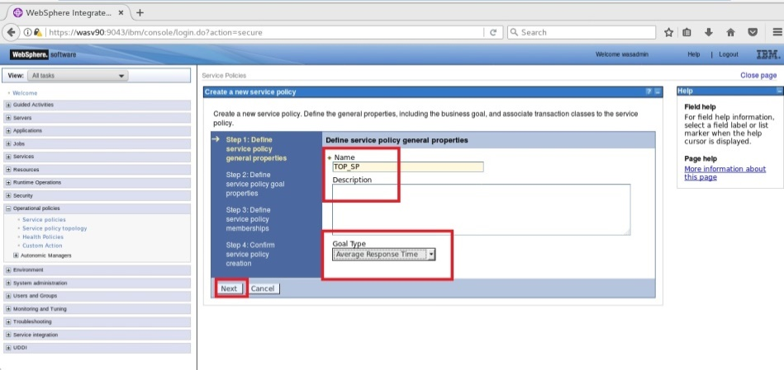

**Step 3:** Enter “Goal Value” as 1, select “Importance” “High” and click “Next”.

Enable Int.Man.

Create ODR

Service Policy

Assoc. Ser.Pol.

Enable Health

Health Policy



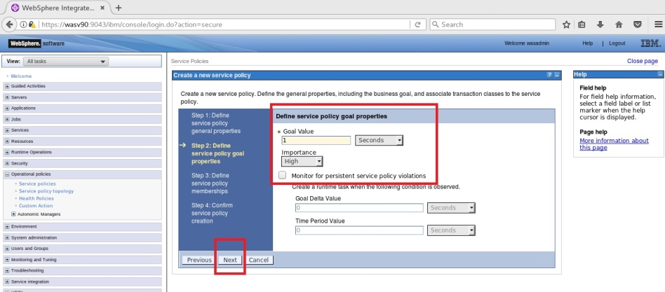

**Step 4:** Click “Next”.

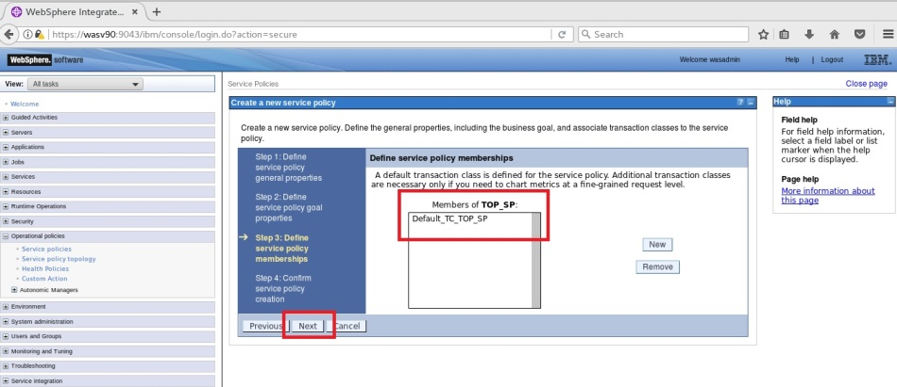

**Step 5:** Click “Finish” to complete policy creation.

Enable Int.Man.

Create ODR

Service Policy

Assoc. Ser.Pol.

Enable Health

Health Policy



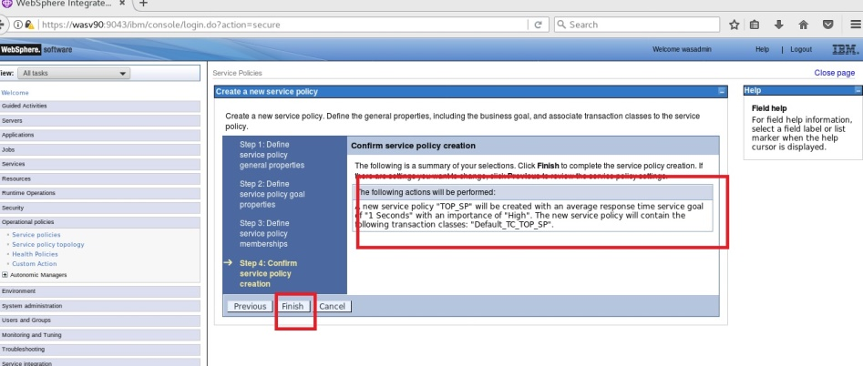

**Step 6:** Click “Save” to write changes to the master configuration.

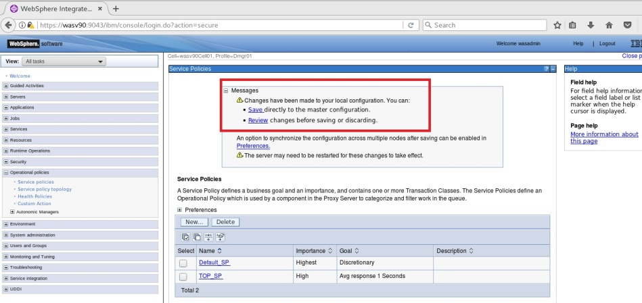

**Task 3 is complete!**

**Task 4: Associate a Service Policy with an Application**

Enable Int.Man.

Create ODR

Service Policy

Assoc. Ser.Pol.

Enable Health

Health Policy



**Step 1:** Navigate to “Applications>Application Types>WebSphere enterprise applications” and click on the application name. (DayTrader2-EE6)

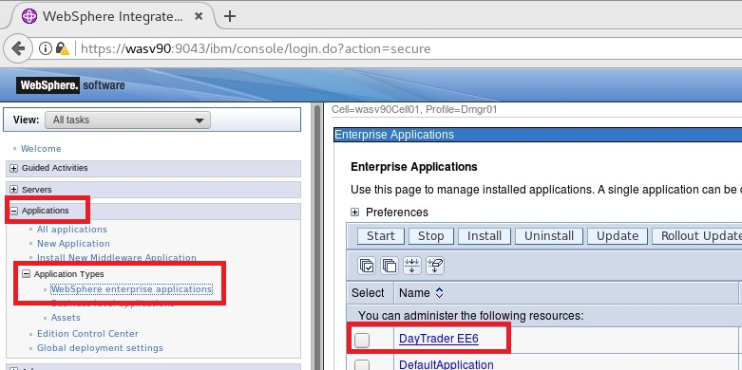

**Step 2:** Navigate to “Service Policies” tab.

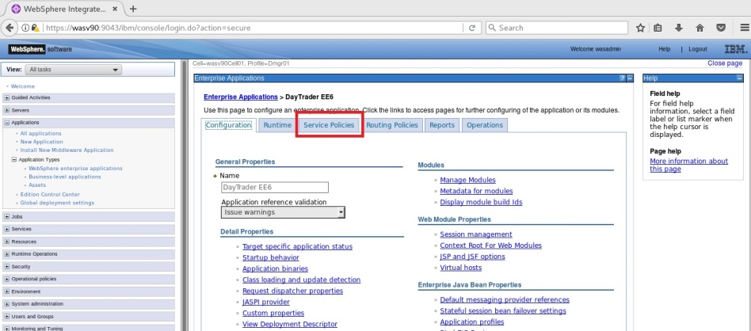

**Step 3:** Click “New” under “Work classes for HTTP requests”.

Enable Int.Man.

Create ODR

Service Policy

Assoc. Ser.Pol.

Enable Health

Health Policy



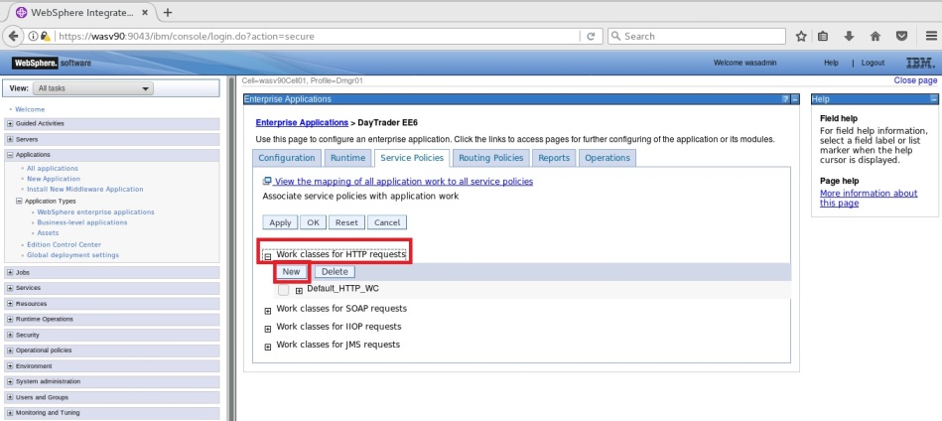

**Step 4:** Enter a name for the work class (Sample_WC) and click “Next”.

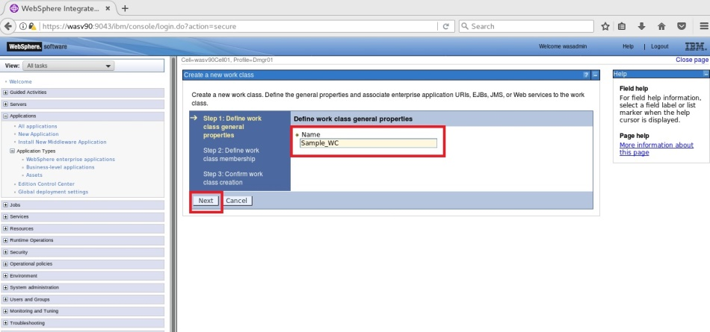

**Step 5:** Select the module (web.rar) from the list, add the “TestServlet” pattern as a member of “Sample_WC” and click “Next”.

Enable Int.Man.

Create ODR

Service Policy

Assoc. Ser.Pol.

Enable Health

Health Policy



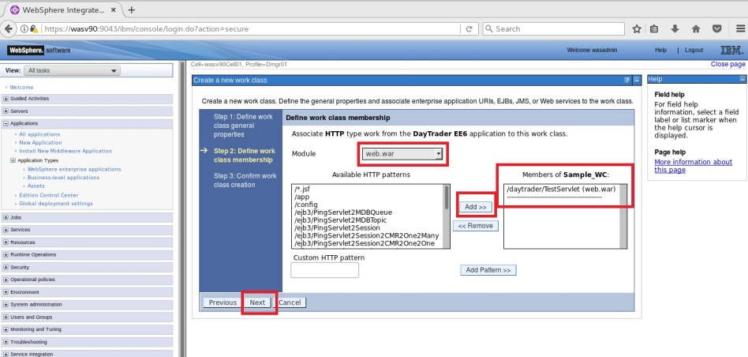

**Step 6:** Click “Finish”.

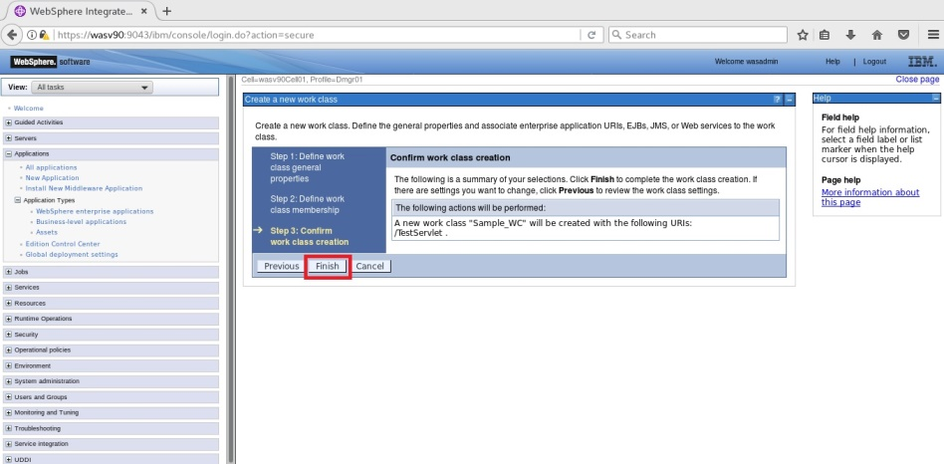

**Step 7:** Select “Default_TC_TOP_SP” (If no classification rules apply, then classify to this transaction class) and click “OK”.

Enable Int.Man.

Create ODR

Service Policy

Assoc. Ser.Pol.

Enable Health

Health Policy



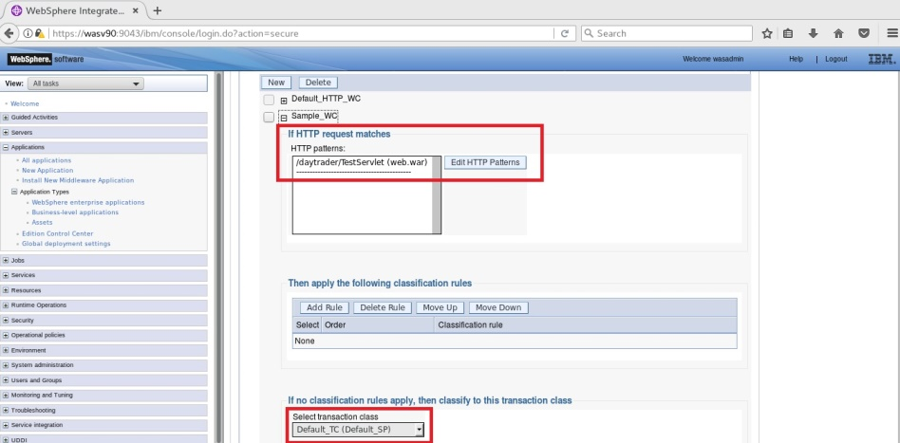

**Step 8:** Click “Save” to write changes to the master file.

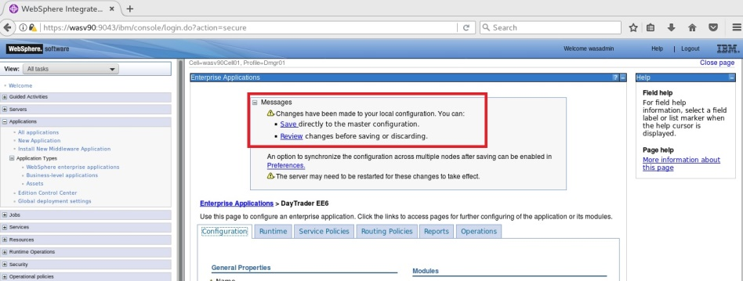

**Step 9:** You can view the service policy topology under “Enterprise Applications>DayTrader-EE6>Service Policy Topology”.

Enable Int.Man.

Create ODR

Service Policy

Assoc. Ser.Pol.

Enable Health

Health Policy



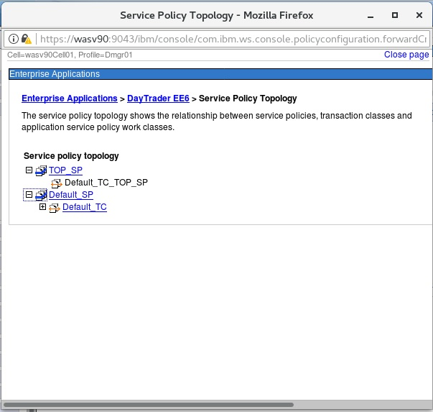

**Task 4 is complete!**

**Task 5: Enable Health Management**

Enable Int.Man.

Create ODR

Service Policy

Assoc. Ser.Pol.

Enable Health

Health Policy



**Step 1:** Navigate to “Operational policies>Autonomic Managers>Health Controller” and select “Enable health monitoring” then click “OK”.

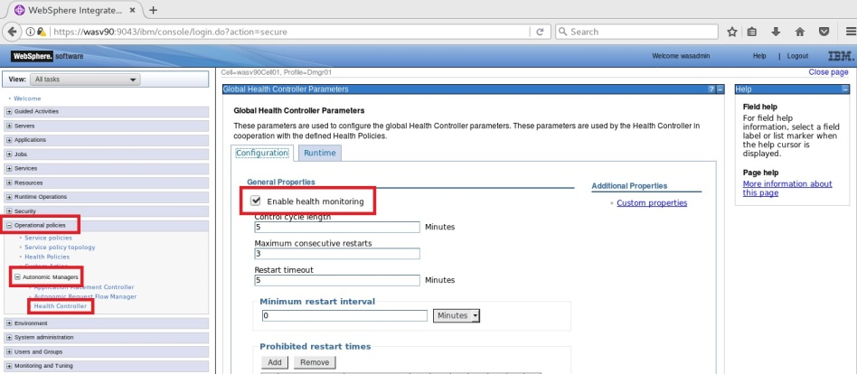

**Step 2:** Click “Save” to write changes to the master file.

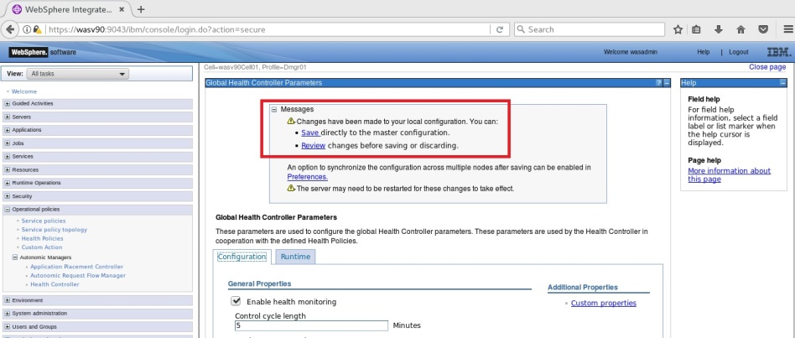

**Task 5 is complete!**

**Task 6: Create a Health Policy**

Enable Int.Man.

Create ODR

Service Policy

Assoc. Ser.Pol.

Enable Health

Health Policy



**Step 1:** Navigate to “Operational policies>Health Policies” and click “New”.

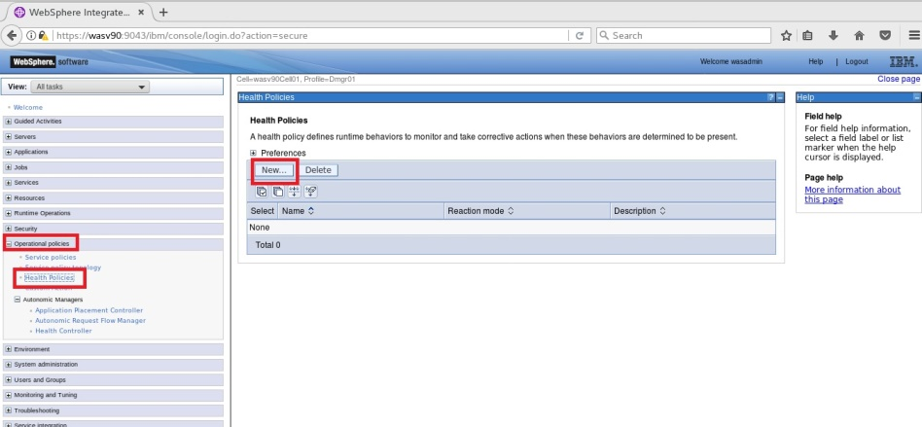

**Step 2:** Enter a name (Sample_HP) and select “Aged-based condition” under “Health condition>Predefined health condition”.

Enable Int.Man.

Create ODR

Service Policy

Assoc. Ser.Pol.

Enable Health

Health Policy



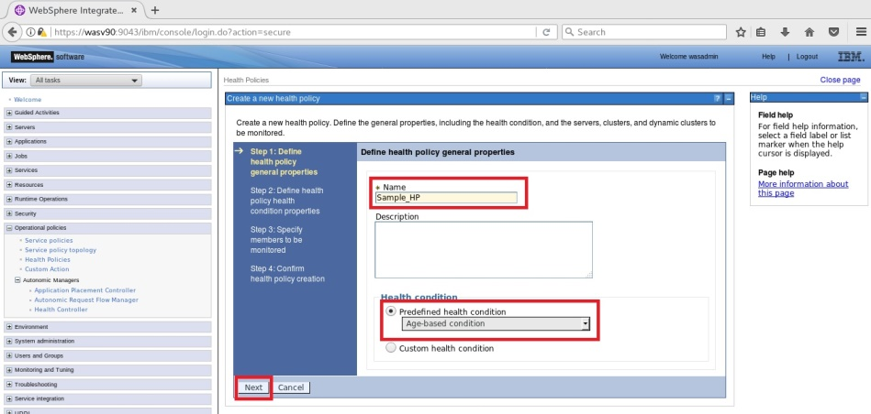

**Step 3:** Enter “7” for “Maximum age (days)” and select “Supervise” as “Reaction mode” then click “Next”.

Enable Int.Man.

Create ODR

Service Policy

Assoc. Ser.Pol.

Enable Health

Health Policy



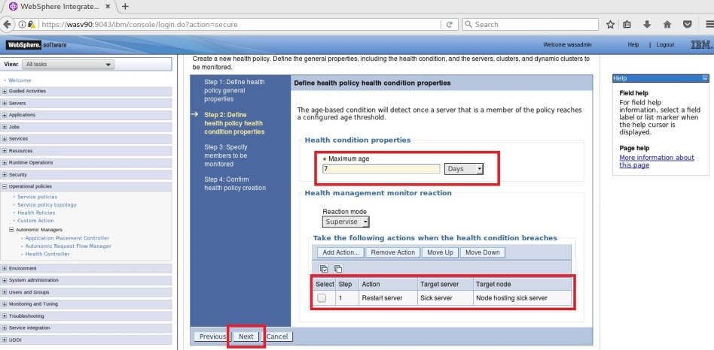

**Step 4:** Select “Clusters” from “Filter by” and add “WAS_Cluster” as a member to “Sample_HP”.

Enable Int.Man.

Create ODR

Service Policy

Assoc. Ser.Pol.

Enable Health

Health Policy



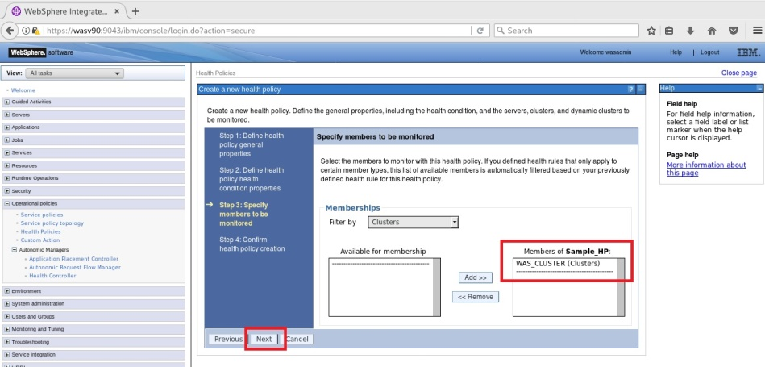

**Step 5:** Click “Finish” to complete”.

Enable Int.Man.

Create ODR

Service Policy

Assoc. Ser.Pol.

Enable Health

Health Policy



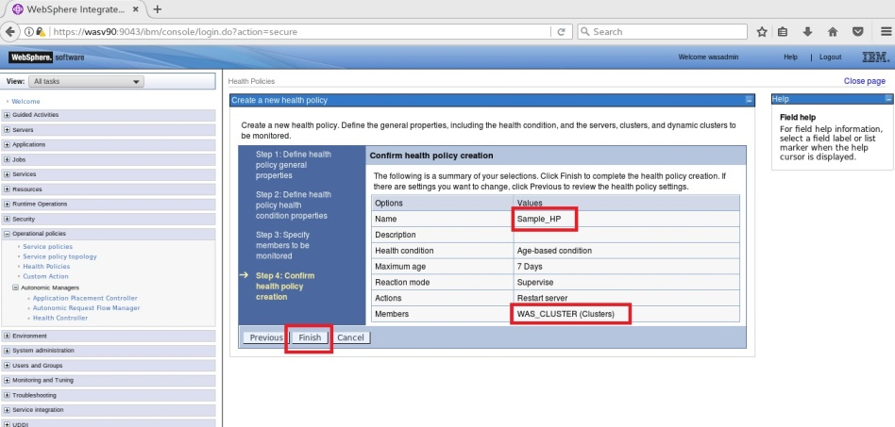

**Step 6:** Click “Save” to write changes directly to the master configuration file.

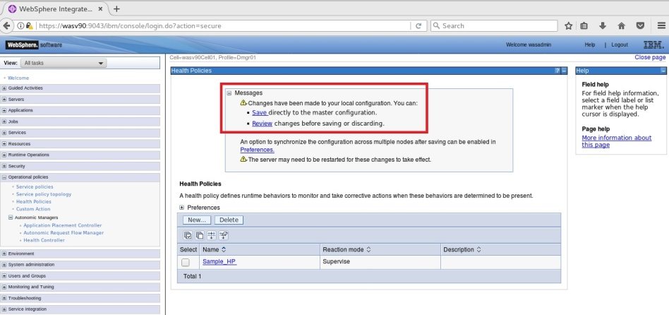

**Task 6 is complete!**

# SUMMARY

Intelligent management is the integration of WebSphere Virtual Enterprise into WebSphere Application Server Network Deployment version 8.5 that provides capabilities autonomic components responding dynamically to the real time conditions of WebSphere environment. ODR is an intelligent proxy that performs request prioritization, flow control, and dynamic workload management. Service policies define the performance goals where health policies specify application server’s status and actions where health management monitors and takes appropriate actions that are defined in health policies.

# REFERENCES

* http://publib.boulder.ibm.com/infocenter/tivihelp/v63r1/index.jsp?topic=%2Fcom.ibm.itcamfapps_ad.doc_72%2Fplanning_an_installation%2Fwebsphere_virtual_enterprise.html
* http://www-01.ibm.com/software/websphere/subscriptionandsupport/compare-was-versions.html
* https://www.ibm.com/developerworks/community/wikis/home?lang=en#!/wiki/WebSphere+Virtual+Enterprise/page/Best+practices+for+managing+the+on+demand+router

# INDEX

Application edition 391

Autonomic managers 392

Health management 391

Intelligent routing 391

On Demand Router (ODR) 391

Performance management 391